Name:- Omkar Joshi

Roll No:-T511042

Div :- TE(A)

PRATICAL NO:-01

Create an AWS Account

Step 1:
Go to the link https://aws.amazon.com/ and click on the “Create an AWS Account” button present at the top-right corner of your screen.
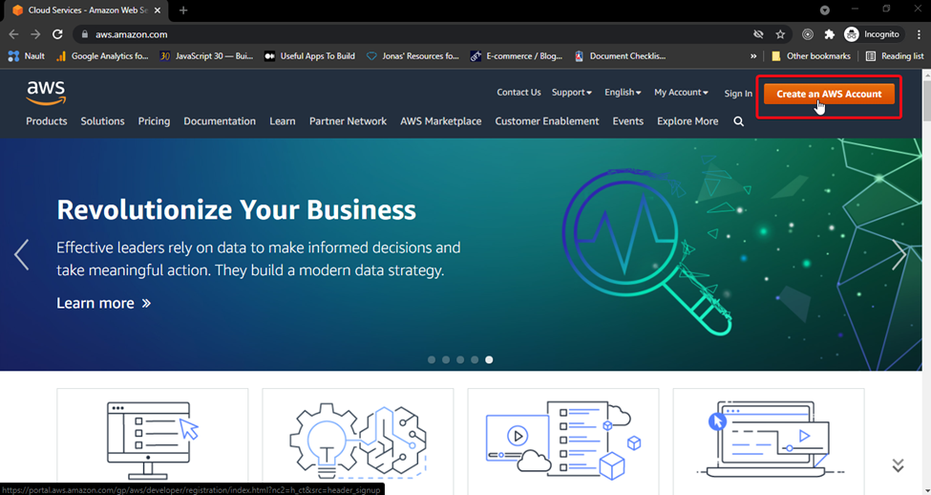

Step 2:
You will be directed to the page with the “Sign-up” form. Fill up the form correctly and click on the “Continue (step 1 of 5)” button.
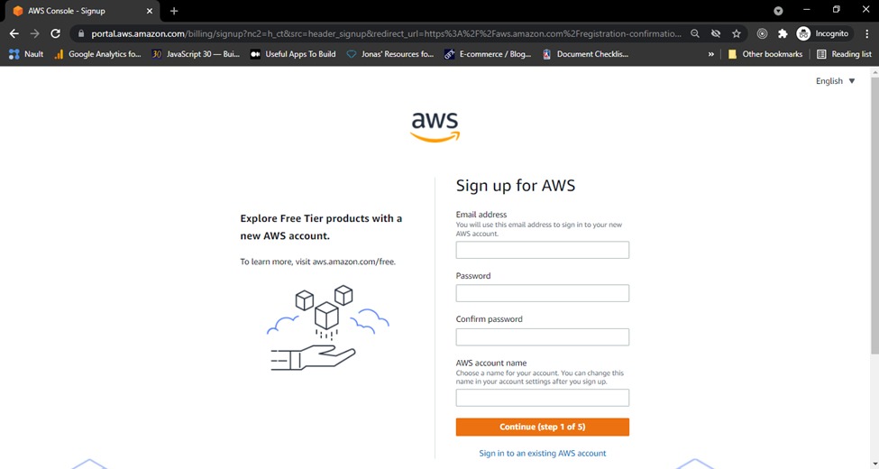
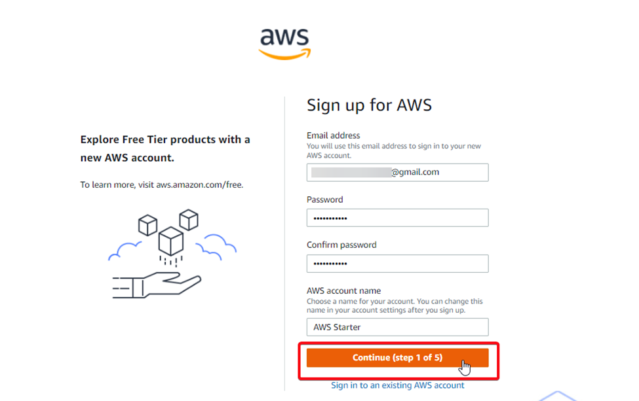
Filling up the signup form and clicking “Continue (step 1 of 5)” button to submit the form

Step 3:
On clicking the button, you will be displayed a captcha field for security purposes. Fill up the captcha field correctly and again click on the “Continue (step 1 of 5)” button.
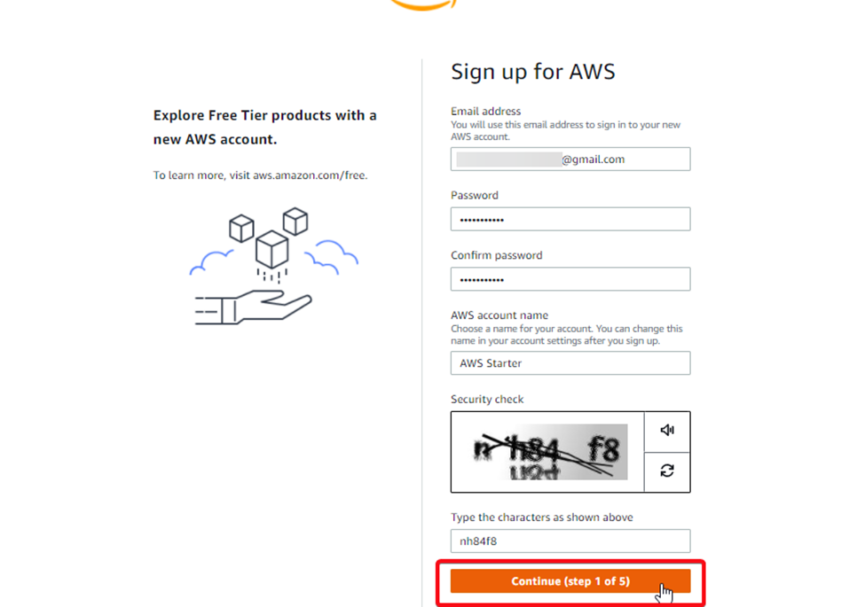

Step 4:
You will be directed to the next form intended to collect your contact information. Fill up the form with your correct contact information (your phone number will be required for verification later), checkmark the check box stating “I have read and agree to the terms of the AWS Customer Agreement” button, and finally, click “Continue (step 2 of 5)” button.
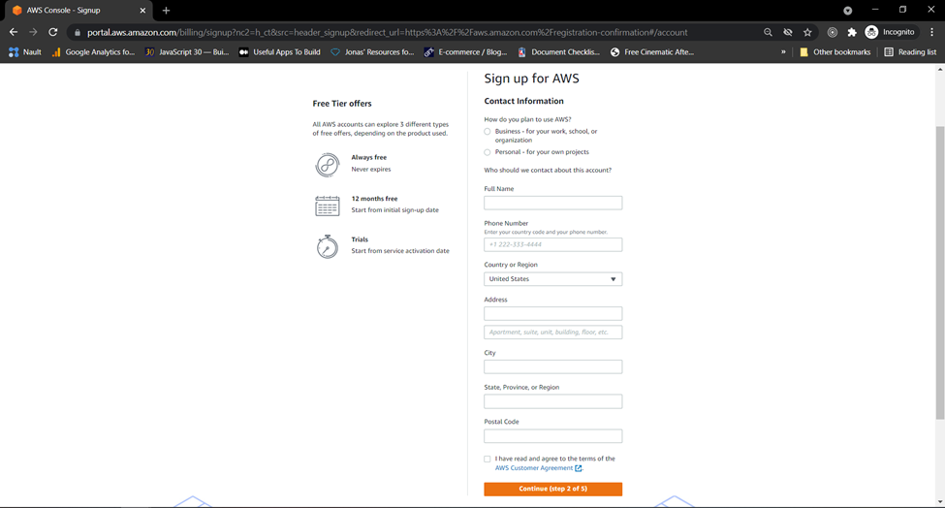
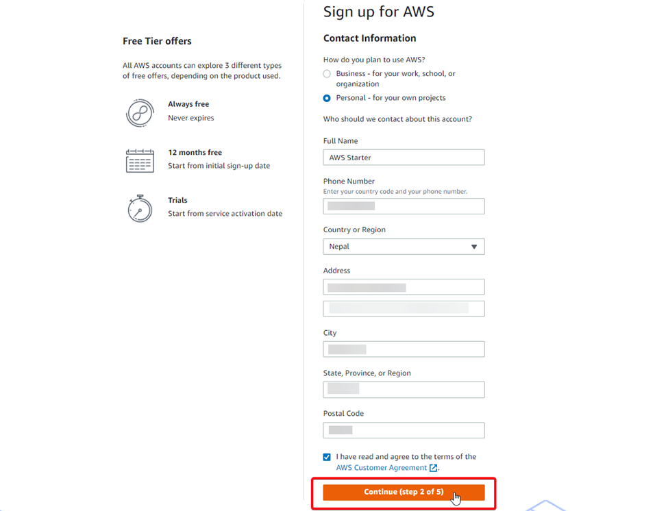
Filling up the contact details and clicking the “Continue (step 2of 5)” button to submit the form

Step 5:
You will be directed to the next form intended to collect the billing information. Fill up your credit card or debit card details, against which you will be billed in the future. Finally, click the “Verify and continue (step 3 of 5)” button.
Note: AWS temporarily holds $1 USD/EUR from your card for 3–5 days to verify your identity, which is released once your identity is verified.
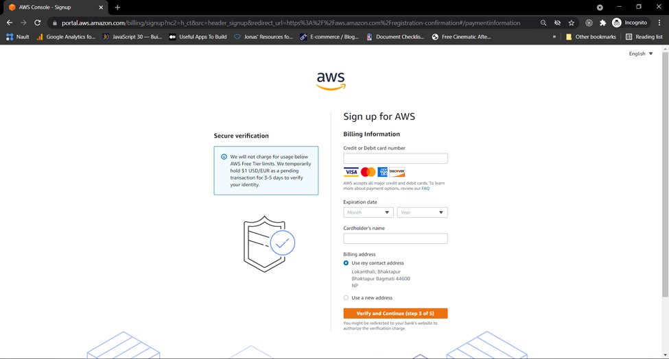
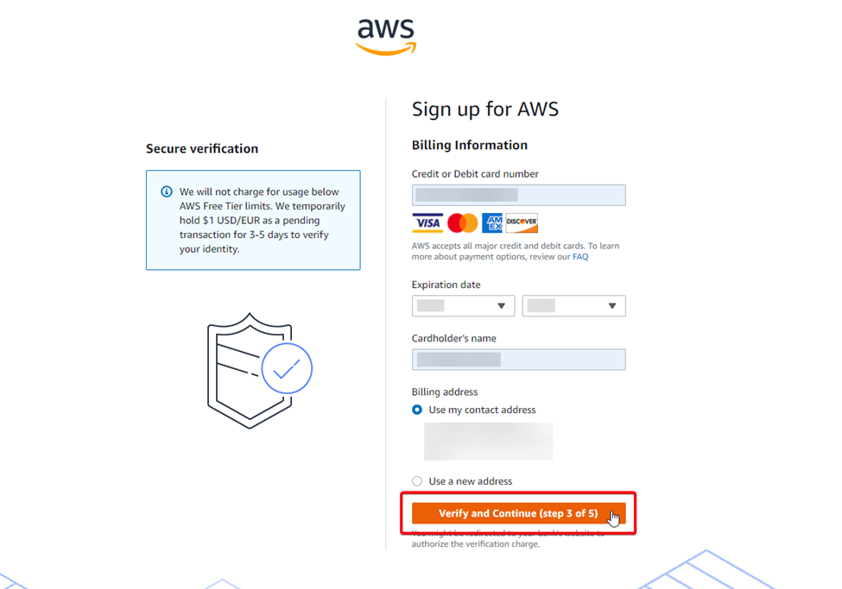
Filling up credit/debit card details and clicking the “Verify and Continue (step 3 of 5)” button to submit the form

Step 6:
You will be directed to the next form intended to confirm your identity. For you to use an AWS account, AWS needs to verify your phone number, for which an automated system of AWS would contact you on your phone via Text message or voice call and provide you the verification code. Hence, fill up the form with your correct phone number, choose how you want to be contacted, fill up the captcha field correctly, and finally, click the “Send SMS (step 4 of 5)” button.
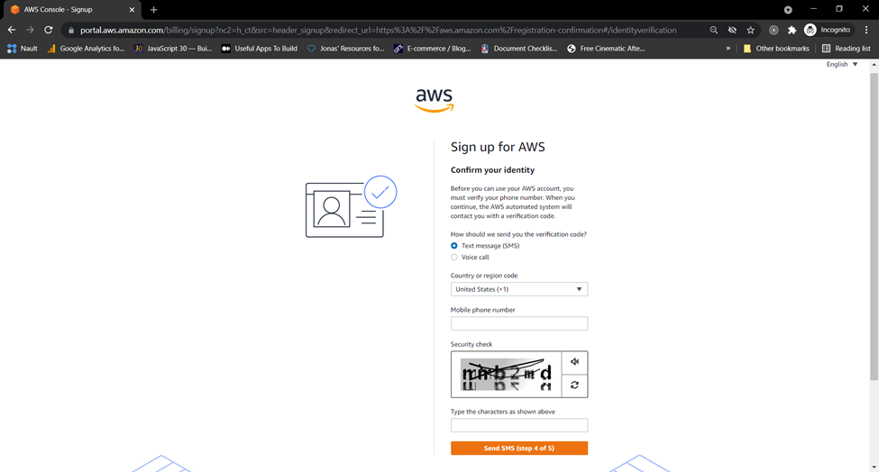
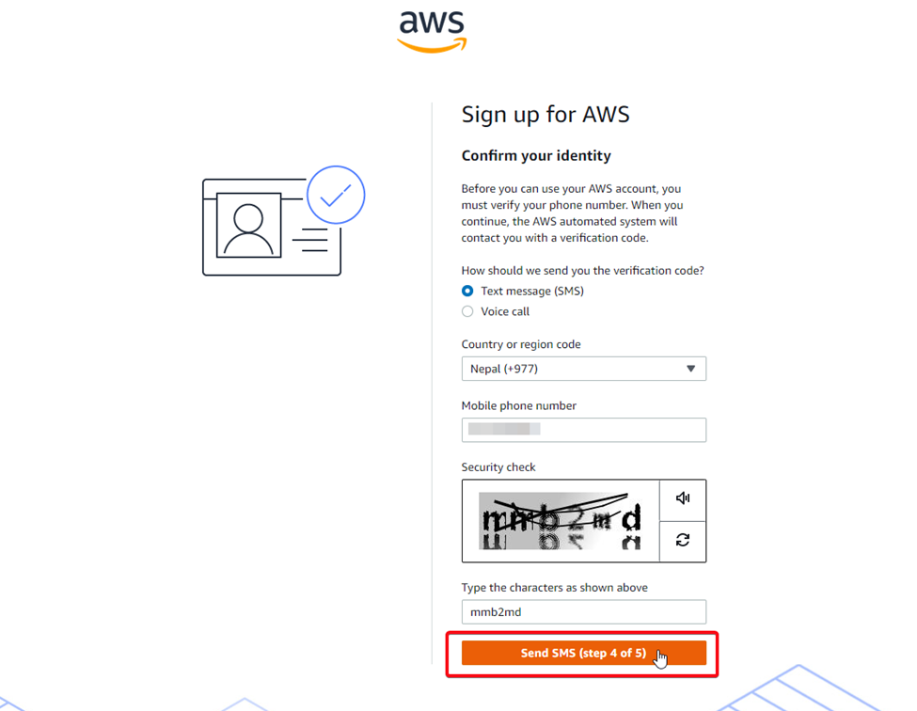
Filling up the phone number and clicking the “Send SMS (step 4 of 5)” button to submit the form

Step 7:
You will be directed to the next form intended to collect the correct verification code sent to your phone number and ultimately verify your identity. Fill up the form with the correct verification code and click the “Continue (step 4 of 5)” button.
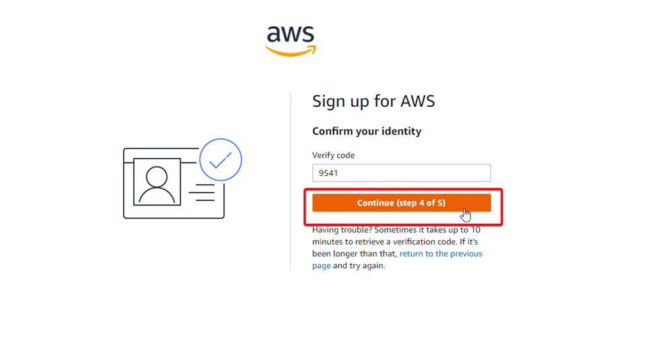
Entering the verification code and clicking the “Continue (step 4 of 5)” button to submit the form

Step 8:
You will be directed to the next form intended for you to choose a support plan from three available support plans (Basic Support, Developer Support, and Business Support). At first, go through the details provided by AWS for each support plan and select a Support Plan which best suits your requirement. Finally, click on the “Complete sign up” button.
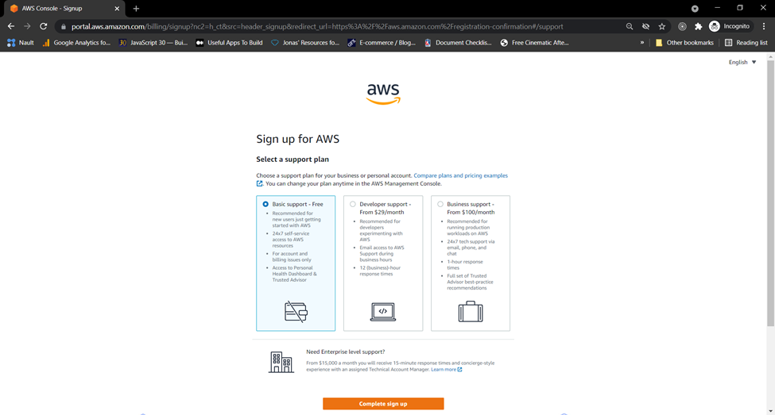
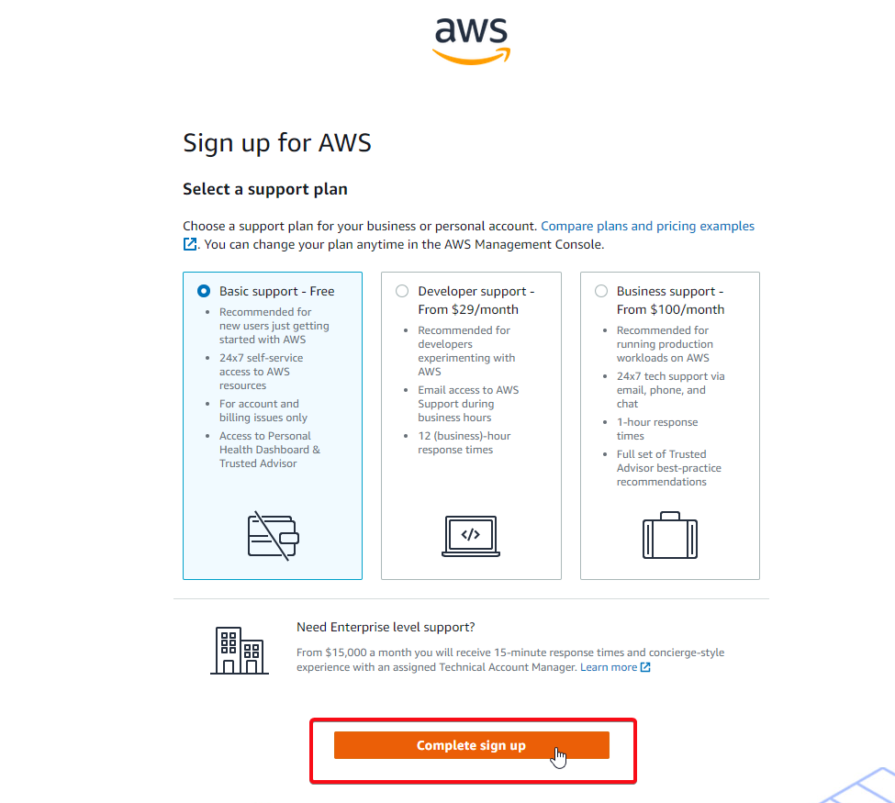
Choosing a support plan and clicking the “Complete sign up” button to submit the form

Sign Up Completed
Once you click the “Complete sign up” button in the previous step (Step 8), your signup process would complete and you will be directed to the page congratulating you for the successful completion of the Sign Up process. It takes a few minutes for AWS to activate your account. Finally, after the activation process is completed at the AWS end, you will receive an email from AWS with your sign-up confirmation details.

